
9:30 - 17:00, Monday 11 November, Stephen Joseph Theatre

A one-day symposium for creative people. Industry speakers, practical workshops, taster sessions and accessible networking. A day of connection, inspiration and learning in a relaxed and inclusive environment. All are welcome!

PLEASE READ THE SCHEDULE BELOW.
Then fill in this google form to book your chosen sessions.

You will be emailed a copy of your choices on completion of the form and we will also share your symposium pathway with you on the day.

The keynote and panels will be Live Captioned and there will
also be roaming BSL support available.

Please outline your access needs when you choose your options. If you would like to discuss them in more detail please email info@hello-arcade.com

9:30 - 10:00 am  Eat Me Café | Arrivals, Registration & Coffee
10:00 - 10:10  The Round | Introduction to the day, housekeeping and welcomes from Stephen Joseph Theatre / ARCADE team.
10:10 - 11:00  The Round | Keynote Panel (all artists and attendees)
Creative Connections
Discussions around the challenges of setting up, sustaining and developing a creative freelance career.
Speakers: Jess Thom (Tourretteshero), Toni-Dee Paul (Artist & Theatre-Maker), Danielle Daglan (Head of Culture North Yorkshire Council)
Chair: Sophie-Drury Bradey (ARCADE)

Access: Live Captioned
11:00 - 11:10 | Comfort / move around the building break(10 mins)

11:10 - 11:55 | Morning Session 1 (choose a 45 min session from the options below)
Option A  Eat Me Bar | Option B  The Round | Option C  The Boden Room | Option D  Rehearsal Room 2
Follow up Q&A session: Danielle Daglan  Danielle Daglan  Q&As with the Head of Culture at North Yorkshire Council with time to learn about Danielle Daglan’s approach in creating the new North Yorkshire Cultural Strategy. | Workshop / Training:  Anti-Racism Training Stella Munthali  Stella is a Racial Activist, Anti-Racism Trainer/Consultant, Racial Equality Advocate. This bitesize training session equips you with the tools and drive to become actively anti-racist in your work and practice. | Workshop / Talk: The Admin of Producing  Amy Fisher  Answering all the questions about managing your artistic projects from budgets and contracts to managing artists and managing your time. A practical session around project management, and budgeting led by Stephen Joseph Theatre Producer Amy Fisher. | Workshop / Talk: Making Work With Young People  Anna Bean & Alice Kynman  Come and enjoy a craft activity and workshop games, with insights and reflections from Anna Bean (visual artist) and Alice Kynman (youth theatre leader) about their experience working with young people.
11:55 - 12:05 | Comfort / move around the building break (10 mins)

12:05 - 12:50 | Morning Session 2 (choose a 55 min session from the options below)
Option A  Eat Me Bar | Option B  McCarthy Theatre | Option C  The Round | Option D  Rehearsal Room 2
Workshop / Talk: Tax for Self-Employed Artists  Vanessa Nolan  Vanessa is a chartered accountant with over 30 years experience across a variety of industries, including not-for-profit, charities and creative arts. This session offers practical advice on how to set up as a creative freelancer, and manage the challenges of keeping accounts and self-assessment. | Conversation / Panel 1: Visual Arts  Jason Wilsher-Mills / Vickie Bissett (Crescent Arts)  Jason Wilsher- Mills is a disabled artist who creates sculptures, which are best described as 'I, Daniel Blake' meets 'The Beano'.  In this panel he talks about his work and practice with Director of Crescent Arts, Vickie Bissett.  Live Captioned | Workshop / Talk: Inclusive Practice  Matt Harper-Hardcastle (Next Door But One Theatre)  As an LGBTQ+ and disability-led theatre company, Next Door But One specialises in promoting creative skills and encouraging community cohesion, particularly with those who face barriers to accessing the arts. In this session Artistic Director Matt shares his experience around gender, inclusion and growing a person-centred way of working. | Workshop / Talk: Telling Your Story  Jack Heaton (Stephen Joseph Theatre)  What’s the story of your business? Who is your audience? What’s the best way to communicate with them? This session will cover the basics of branding and marketing for freelance artists.

12:50 - 14:00  12:50 - 14:00  Eat Me Café | Lunch

14:00 - 14:45 | Afternoon Session 1 (choose a 45 min session from the options below)
Option A  Eat Me Bar | Option B  McCarthy Theatre | Option C  The Boden Room | Option D  Rehearsal Room 2
Workshop / Talk: Making Artist Access Riders  Toni-Dee Paul  A session to support you through the process of making and embedding the use of access riders into your creative practice. | Conversation / Panel 2: Music  Stewart Baxter / Ysabelle Wombwell / Chiedu Oraka  Chair: Kristina Jones (Beckview Studios)  Creative discussion around music, production, promotion, gigging and self-producing.  Live Captioned | Workshop: Public Speaking for Creatives  Elizabeth Boag  Elizabeth Boag has worked as a corporate actor and facilitator specialising in communication skills since 2006. In this practical session to support you in speaking up and presenting your best self. | Workshop / Talk: Working in Ceramics  Rebecca Norris  Rebecca runs workshops, courses and pottery experiences in the Scarborough area. In this session you can explore working with air-dry clay while Rebecca shares more about her arts practice working as a ceramicist as well as her experience on the Great Pottery Throwdown.
14:45 - 14:55 | Comfort / move around the building break (10 mins)

14:55 - 15:50 | Afternoon Session 2 (choose a 55 min session from the options below)
Option A  Eat Me Bar | Option B  McCarthy Theatre | Option C  The Boden Room | Option D  Rehearsal Room 2
Workshop / Talk: Working With Schools & Libraries  Hayley Clark (ER Library) & Christine Rostron (ARCADE Education Producer) & Lee Taylor (Scarborough Library)  A discussion around connecting, creating and making work in schools and libraries. | Conversation / Panel 3: Theatre  Lydia Marchant / Sarah Penney (Middle Child) / Paul Robinson  Creative discussion around making, writing and programming theatre.  Live Captioned | Workshop / Talk: How to Fund Your Work  Rach Drew  Rach Drew will suggest ways to fund your work, share fundraising tips and answer your questions about writing bids. | Workshop / Talk: Space  to Be  Jayne Shipley  Enjoy a wellbeing arts session and craft activity and hear more about the Scarborough Museums community space, Space to Be.
15:50 - 16:05 | Break (15 mins)

16:05 - 16:50 | Open Space & Networking (all artists and attendees)  The Round
An opportunity to come together, reflect on learnings from the day and take part in inclusive networking and connection.
Led by team ARCADE.
16:50 - 17:00 | Thank you and goodbyes

ARTIST & SPEAKER INFO

Keynote Panel

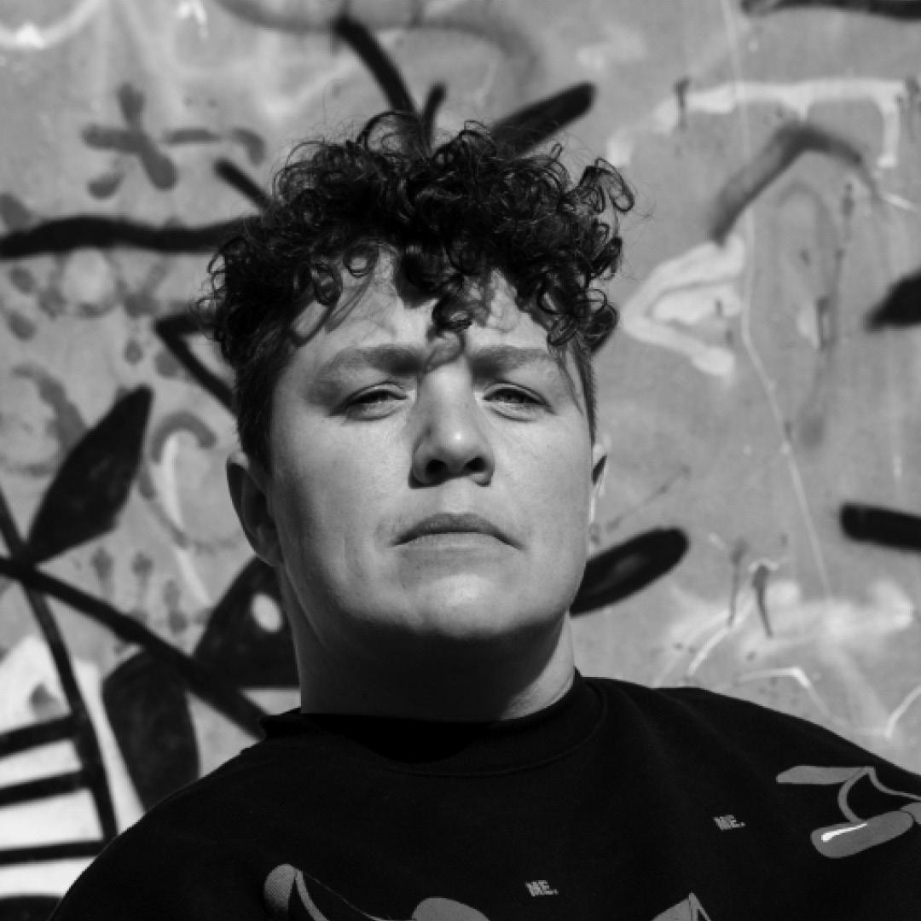
Jess Thom (she/her)
Writer, artist and activist Jess Thom co-founded Touretteshero in 2010 as a creative response to her experience of living with Tourette’s Syndrome. Jess campaigns for disability rights and social justice and is on a mission to change the world ‘one tic at a time.’ A multi-award-winning BAFTA nominated performer, Jess has toured the world with sell out stage shows, stand-up comedy, keynotes speeches and public appearances. Touretteshero is a proudly disabled-led organisation with an established reputation for creativity and making change across sectors. Jess frequently contributes to academic papers, interviews, and podcasts, to remove barriers and push for greater equality.

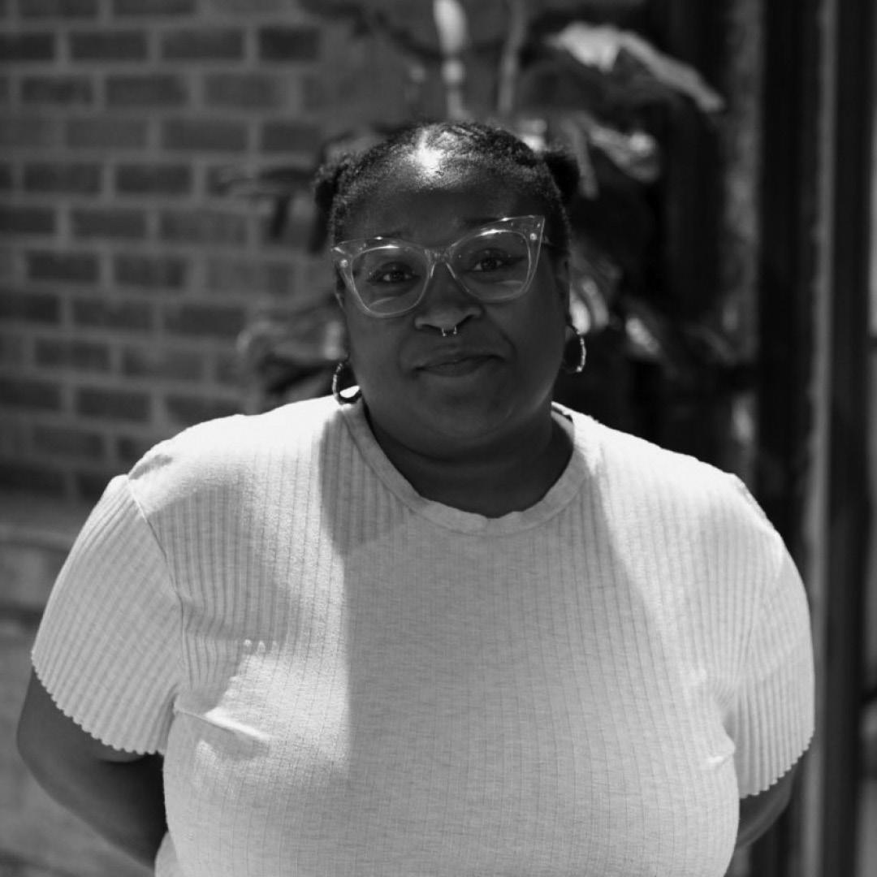
Toni-Dee (she/they)
Toni-Dee is an independent artist and theatre maker working across form, a writer (In Other Words, Field Notes), workshop leader, facilitator, collaborator and ‘thinker-in-the room’. Her current body of work, made with ‘infectious warmth’ (Exeunt) is a series of performances & installations made for cemeteries, refugee centres, kitchens, churches and theatres. Outside of her artistic practice, Toni facilitates new approaches to care and wellbeing for other artists, is Associate Director at Selina Thompson Ltd & Associate Artist of award winning company One Tenth Human making intricate, intimate, and wildly entertaining live imaginative events for children and families. Toni also facilitates part-mutual-care-part-art making-part-activism project Balmy Army and is a Trustee of Leeds based International performance festival Transform.

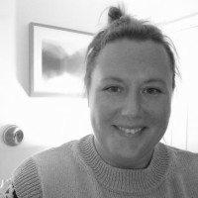
Danielle Daglan - Head of Culture North Yorkshire Council (she/her)
Danielle is the Head of Culture and Archives at North Yorkshire Council and has recently led on a new cultural strategy for the new combined North Yorkshire authority. She has over twenty years’ experience in the cultural sector working across arts, heritage and museums within charitable trusts, national development agencies and with/for local authorities.

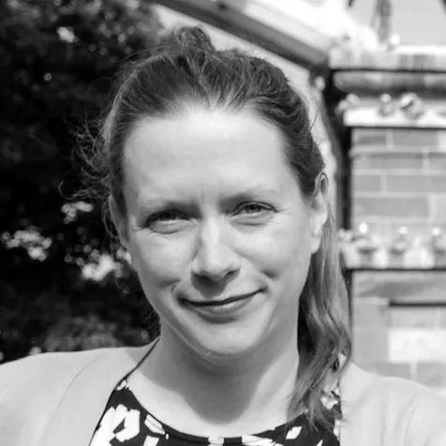
Chair: Sophie Drury - Bradey - Co-Artistic Director & CEO, ARCADE (she/her)
Before co-founding ARCADE, Sophie was Senior Producer for 10 years at Battersea Arts Centre. Part of senior management, she led talent development, managing budgets of £1.2 million & producing ambitious productions including Brand New Ancients by Kate Tempest (Guardian’s 50 Best Shows of the 21 century).

Conversation / Panel 1: Visual Arts
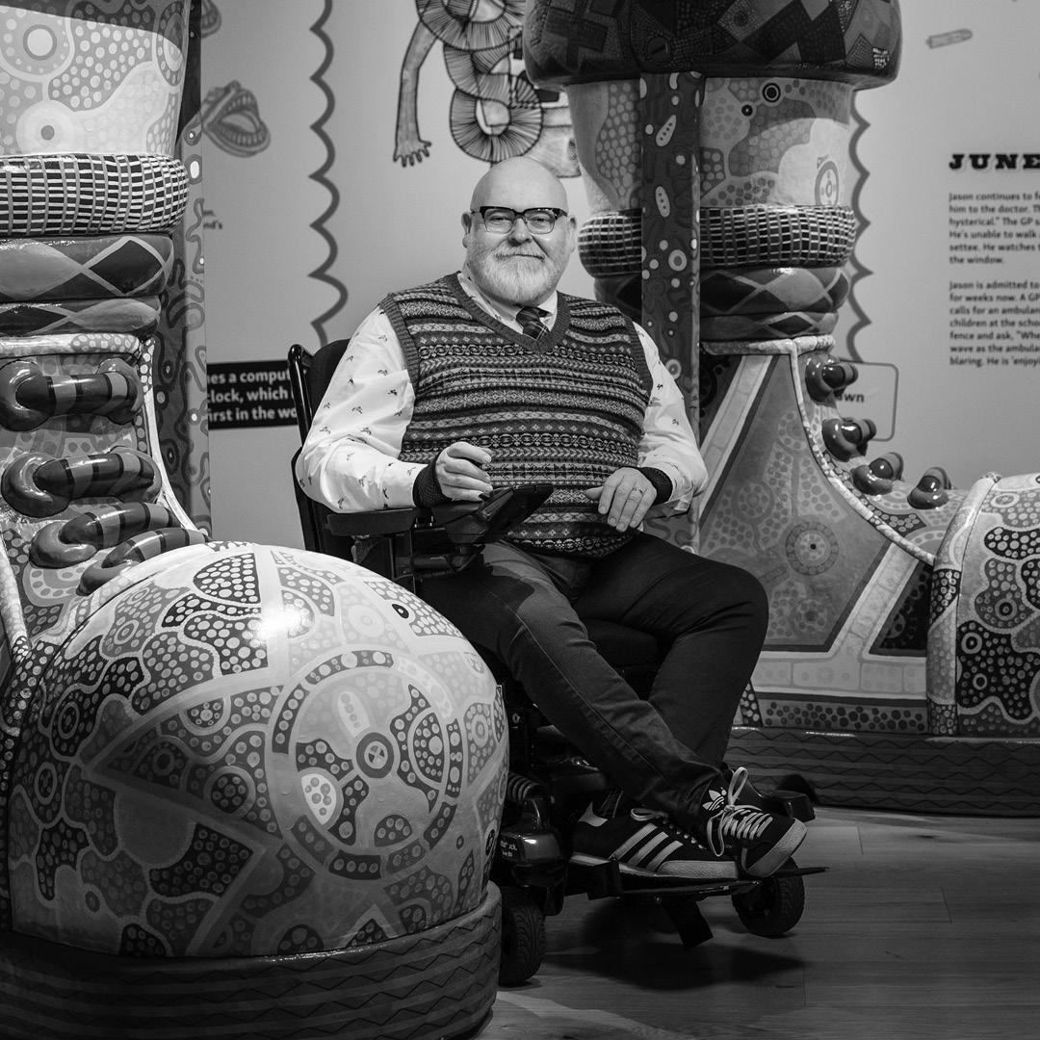

Jason Wilsher-Mills (he/him)

Jason’s work celebrates disability, his northern working-class heritage & popular culture, through cutting edge technologies and brightly coloured, large scale humorous, but challenging art. “When asked what my work is about, I simply say – Think ‘I, Daniel Blake’ meets ‘The Beano’”. Jason uses both digital media and traditional media to create the work, which is brightly coloured and psychedelic, employing a palette inspired by the childhood comic books he read in the 1970s. Jason has exhibited around the world, including the 2024 Venice Biennale and at Wellcome Collection. Photo: Benjamin Gilbert

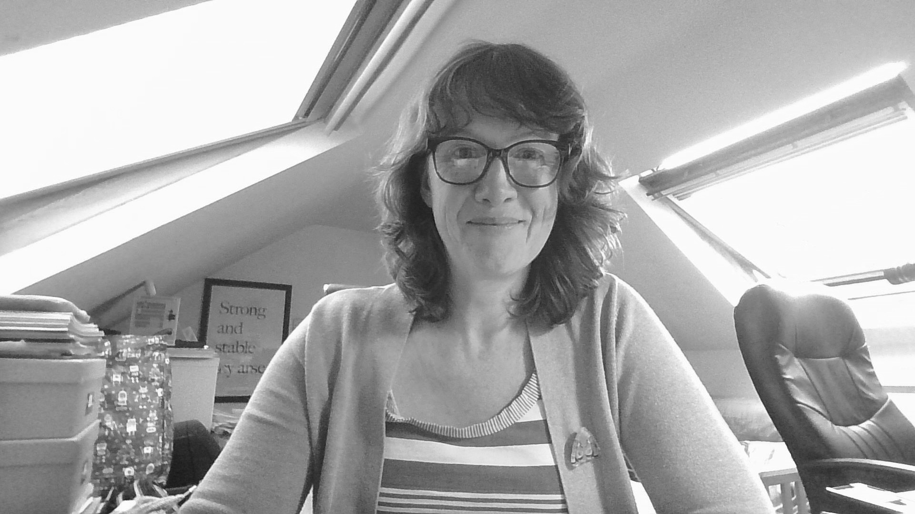
Chair: Victoria Bissett - Director Crescent Arts (she/her)
Victoria Bisset is the Director at Crescent Arts, a visual arts organisation established in 1979 by visual artists living and working in and around Scarborough. She is also completing a PhD at the University of Hull, looking at the practices of cultural mega events, such as city of culture events, and how they develop and deliver community engagement projects.

Conversation / Panel 2: Music

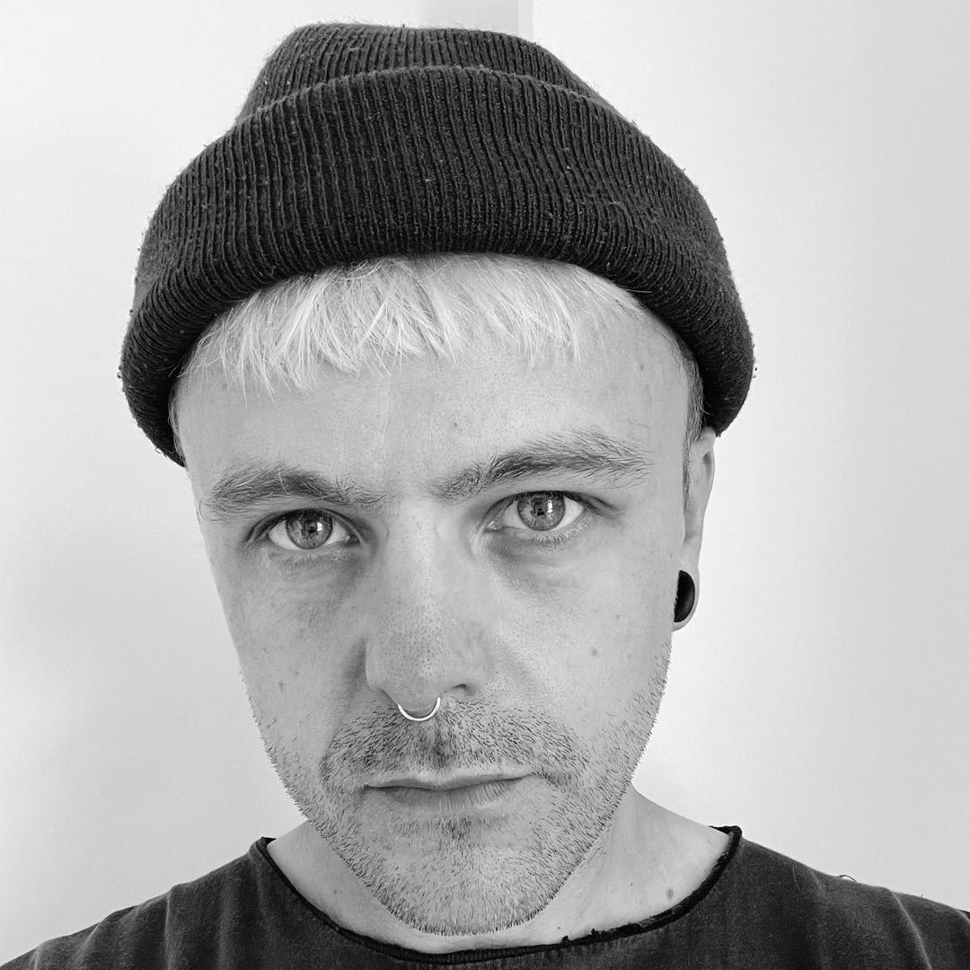
Stewart Baxter (he/him)

Stewart Baxter is an experimental composer, musician and visual artist from Hull where he has built a studio with his band LIFE, and a creative space for his company Hinterland Creative and local artists. Stewart works as an art director within the music industry and runs the Hull Music Net music development project.

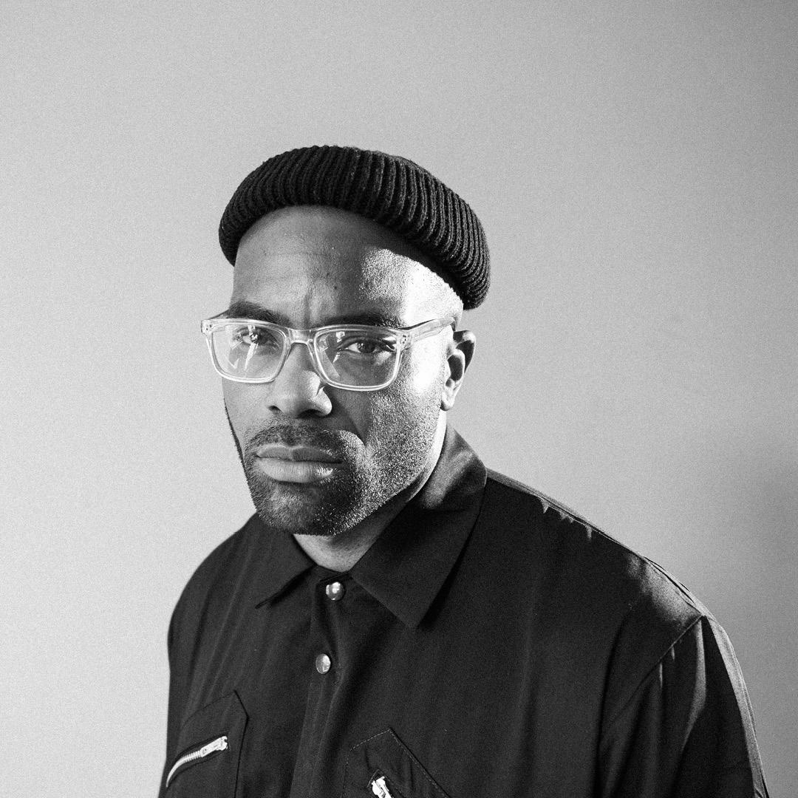
Chiedu Oraka (he/him)
A leading figure in the Northern Rap and Grime scene Chiedu Oraka, aka ‘The Black Yorkshireman’ defies genres with his blend of raw honesty and social poetry. Raised on North Hull Estate, his bars fill the dancefloor as capably as they serve to portray the Black, working-class experience from the frontlines of a largely white, economically deprived region of the north. Delivered in his city’s distinct accent, Oraka is a fierce representative of a new sound and an amplifier of stories yet to be told. Photo: Luke Hallet

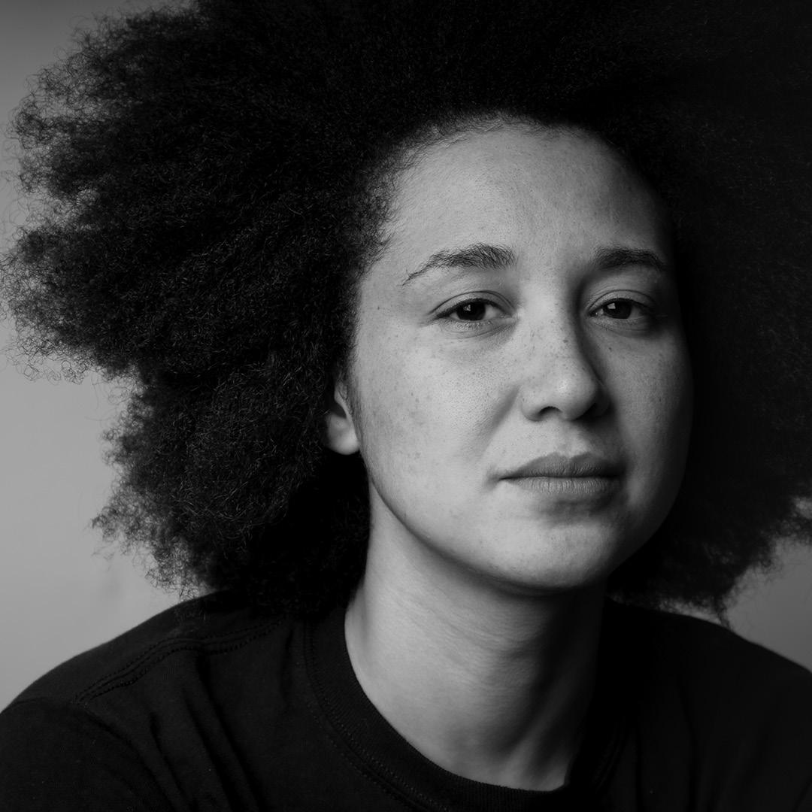
Yssabelle Wombwell (she/her)
Ysabelle Wombwell is a composer, music producer and recording artist. She has been involved with grass roots music in Yorkshire for the past 15 years, producing, performing solo and as part of various ensembles. As well as her own releases, many of her productions have had international and national airplay including on BBC6 Music, BBC Radio 1 and 2. Photo: Jordan Dean

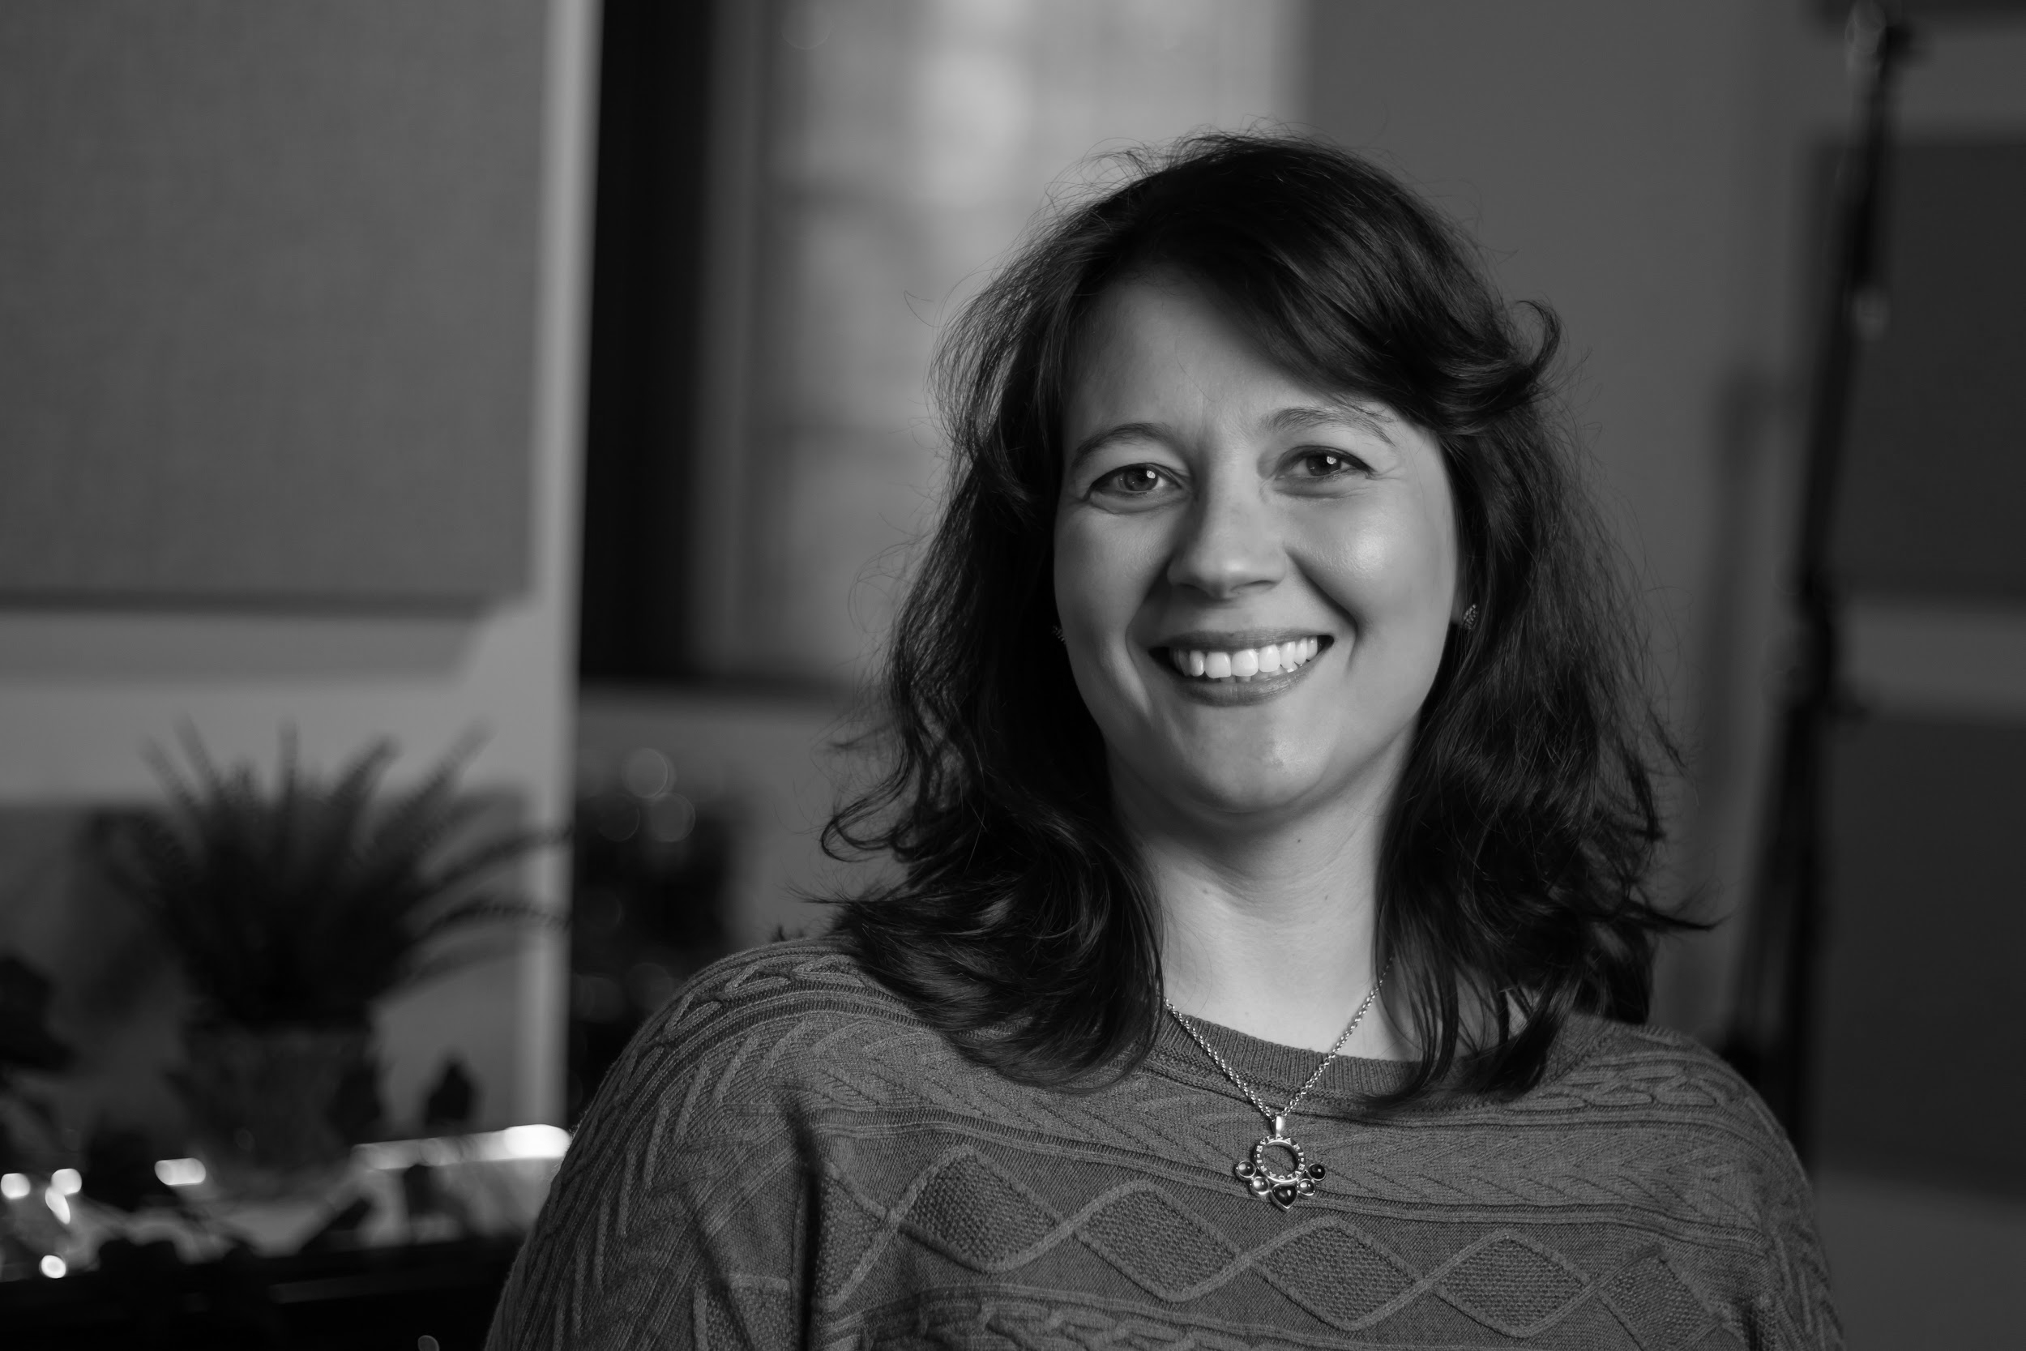
Chair: Kristina Jones - Beckview Studios (she/her)
Kristina, Studio Manager at Beckview Studios in Scarborough, oversees daily operations and collaborations with diverse clients. With a background in Theatre and a Master's in Management, she drives success in arts and music. Committed to supporting regional arts and economic growth through her work at the studio. Photo: Daniel Abell

Conversation / Panel 3: Theatre

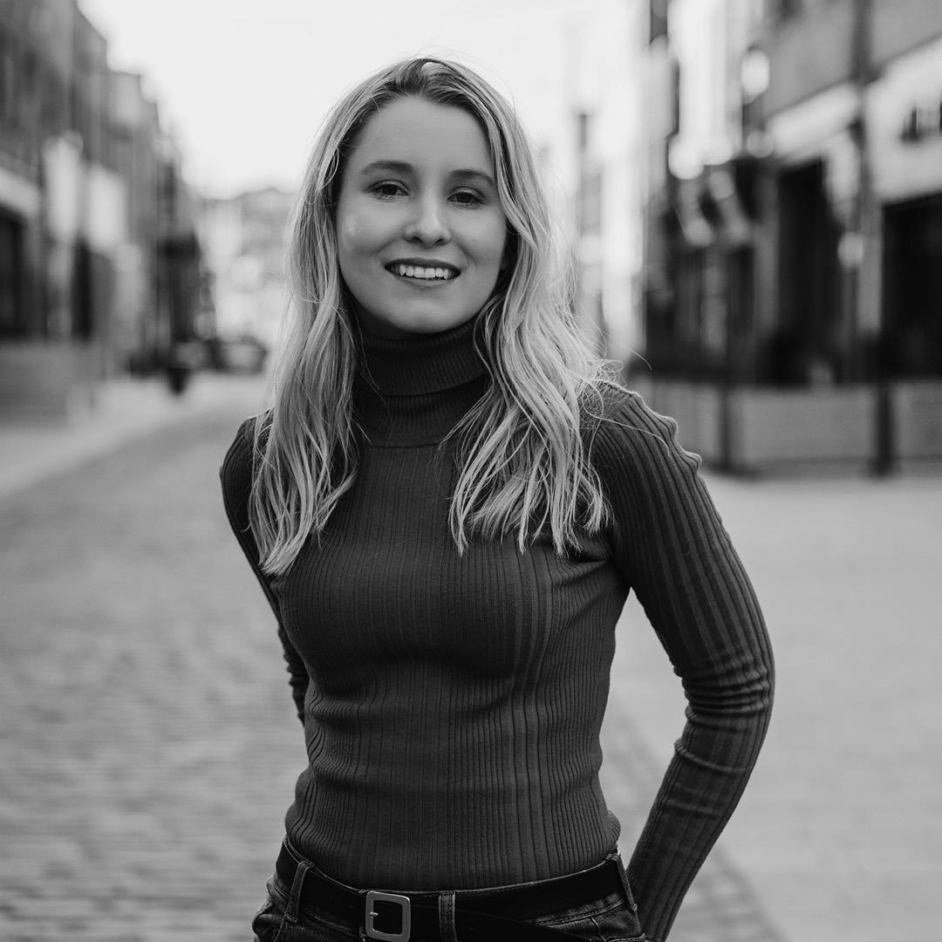
Lydia Marchant (she/her)
Lydia Marchant is a writer for stage, screen and audio. Her debut play MUMSY premiered at Hull Truck Theatre in March 2023 and is published by Nick Hern. She was part of the BBC Writers Academy, has worked on Casualty and Holby City and is a regular writer for EastEnders. Photo: Matthew Cooper

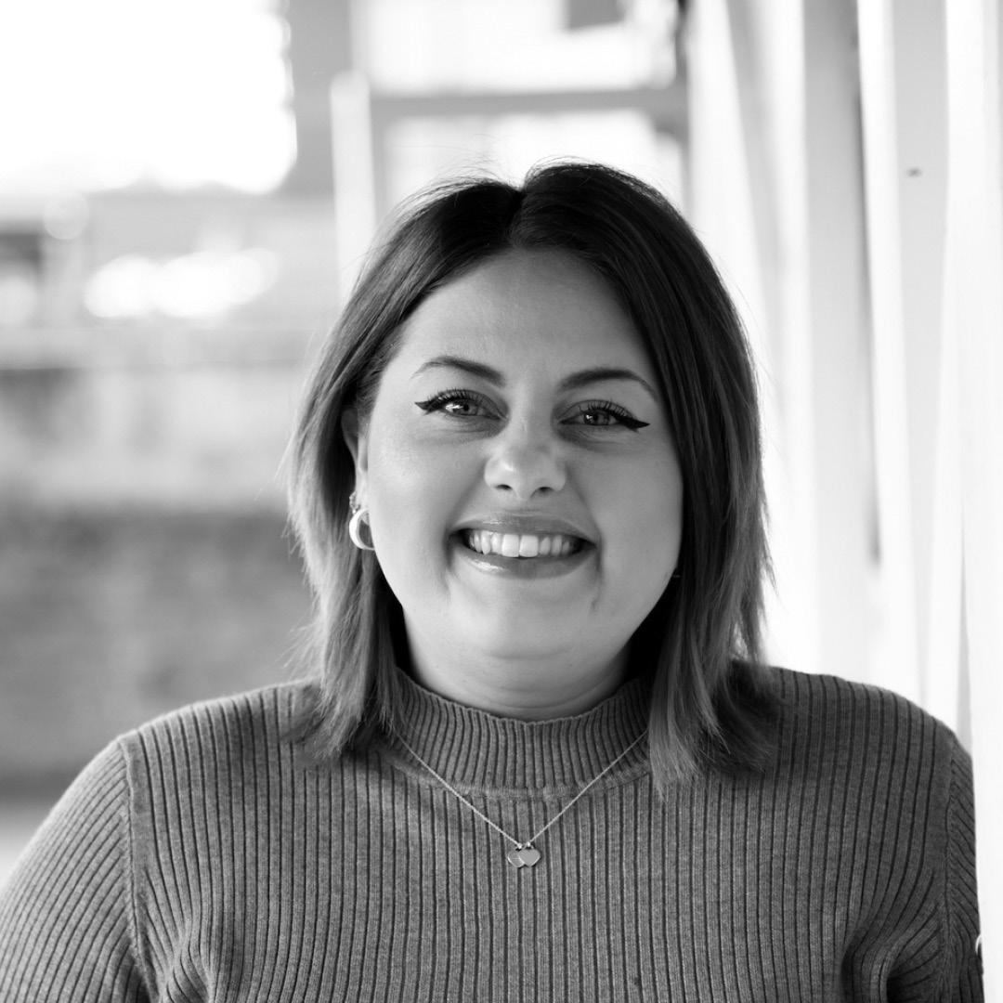
Sarah Penney - Middle Child Theatre (she/her)
Sarah Penney is the senior producer of Middle Child. Sarah has worked on large-scale outdoor projects, new writing theatre productions, Fringe shows, exhibitions, artist development and community engagement programmes and more, managing budgets, partners, funding and creative teams. Her producing ethos has transparency, integrity, wellbeing and kindness at its core. Photo: Matthew Booth

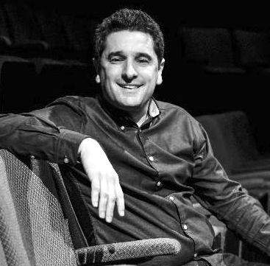
Paul Robinson - Stephen Joseph Theatre (he/him)
Paul Robinson is the Artistic Director and joint CEO of Stephen Joseph Theatre. Paul was Joint Artistic Director of Theatre503 from 2007 to 2012, during which time the theatre was turned into a multi-award-winning new writing powerhouse. Paul has been twice nominated for Best Artistic Director at the Off West End Awards. His first feature length film And Then Come the Nightjars (Finite Films and TV) was released in autumn 2023. Photo: Tony Bartholomew

Other Speakers & Artists
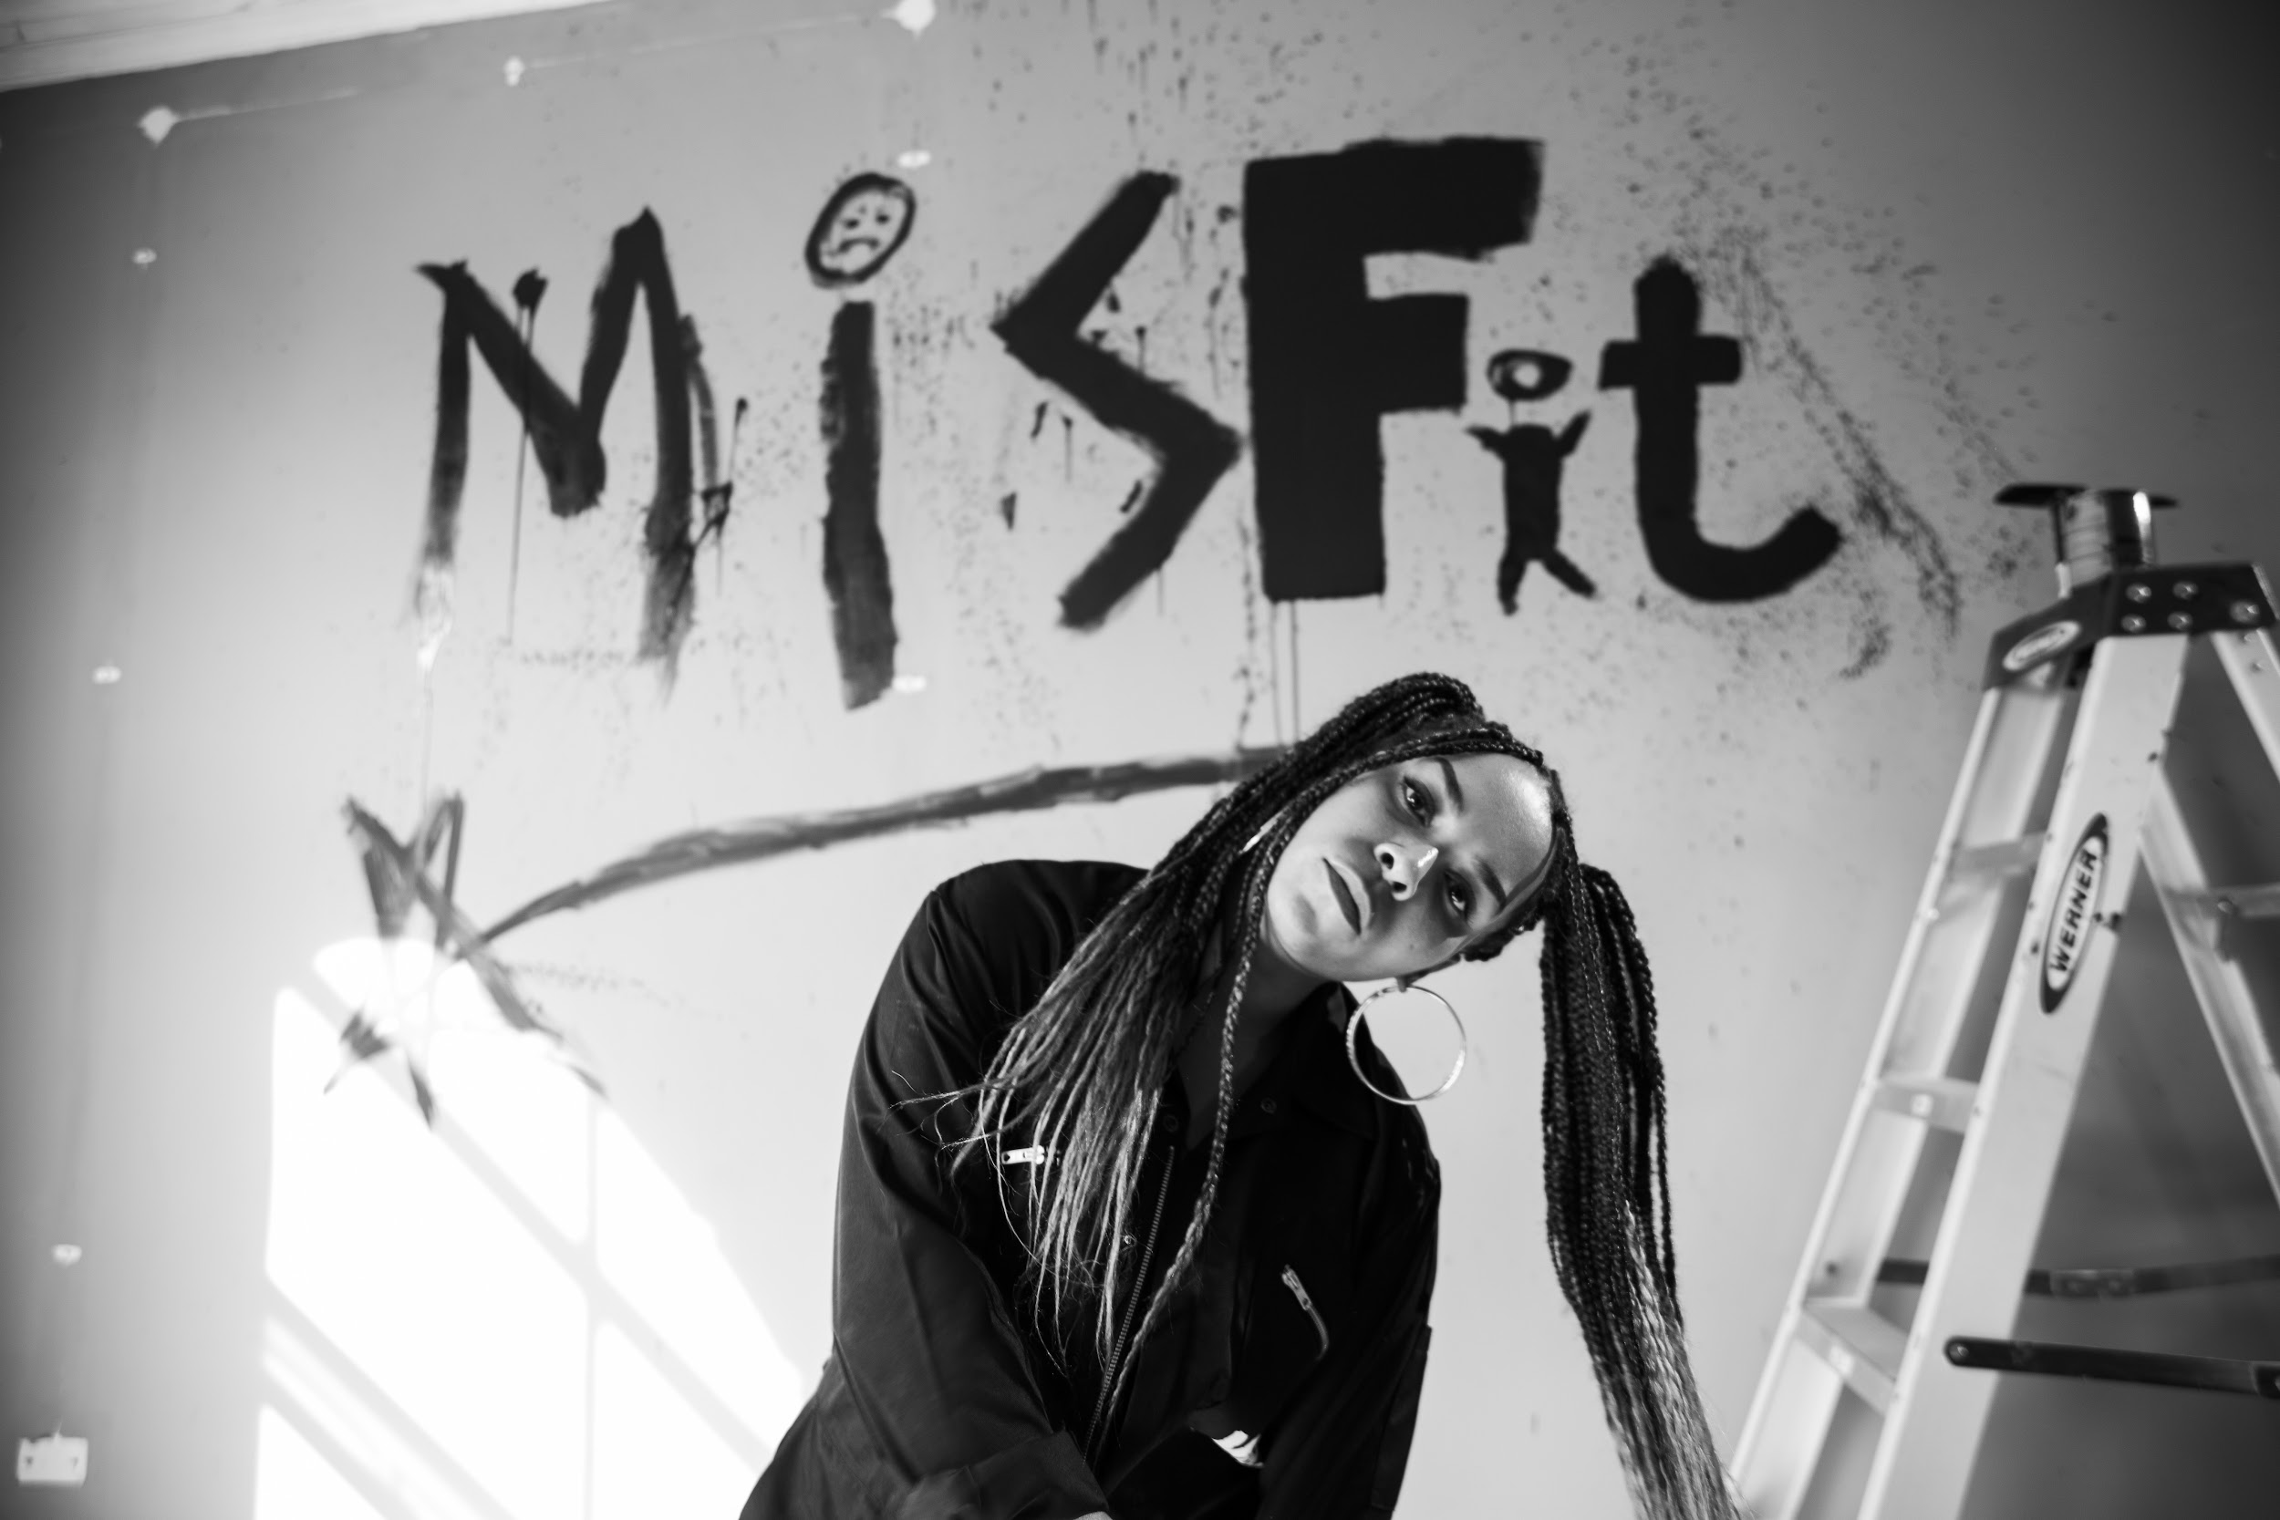
Stella Munthali (she/her)
Workshop / Training: Anti-Racism Training with Stella Munthali
Stella is a Racial Activist, Anti-Racism Trainer/Consultant, Racial Equality Advocate. BA Hons Social Work (10 years) Cultural Creative Collaborator and Host of monthly safe spaces for those who are racially marginalised. Photo: Luke Hallet

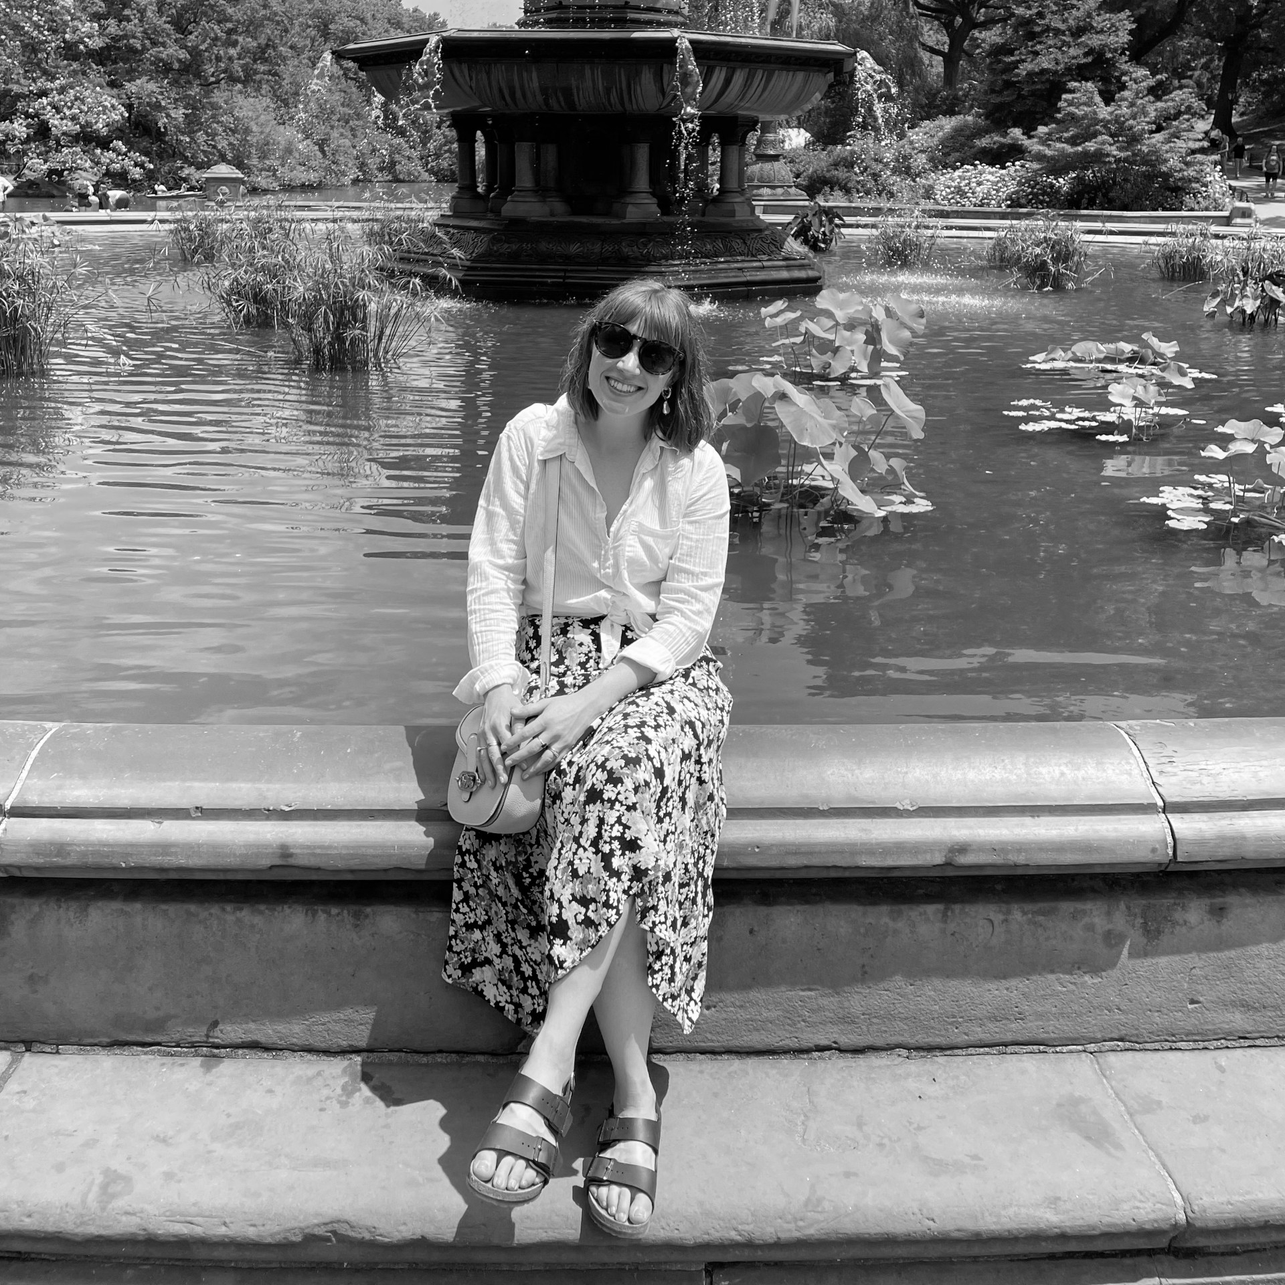
Amy Fisher - Stephen Joseph Theatre (she/her)
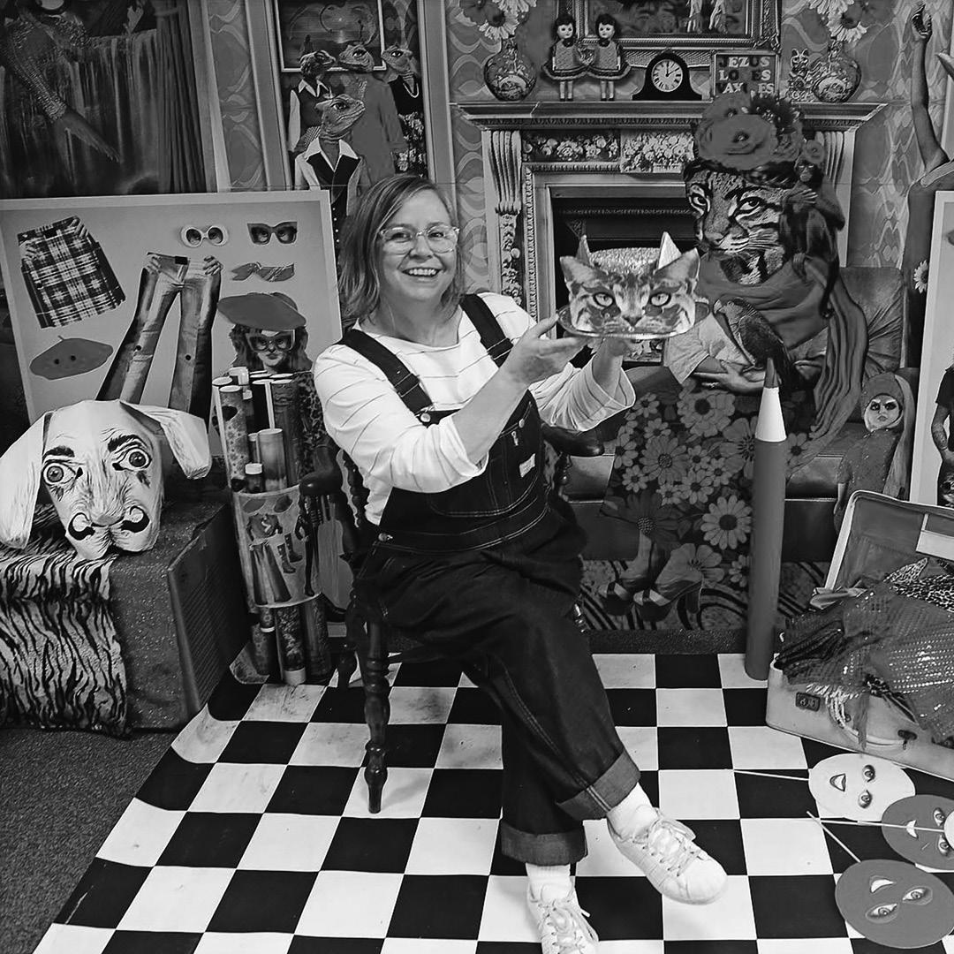
Amy is a Theatre Producer and currently the Producer and Programmer at Stephen Joseph Theatre. Amy has been working as a producer for 10 years in a range of capacities as a freelancer and with venues on a variety of projects including touring, co-productions, participation projects and site specific work.
Anna Bean (she/her)
Workshop / Talk: Making Work With Young People
Anna Bean is a Hull-based visual artist who works on both commissioned and personal projects. She uses a range of materials and processes including photography, filmmaking, collage and animation techniques and creates and facilitates art workshops with a wide range of community groups. Photo: Anna Bean
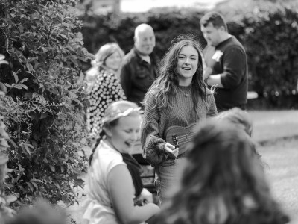
Alice Kynman - Stephen Joseph Theatre (she/her)
Workshop / Talk: Making Work With Young People
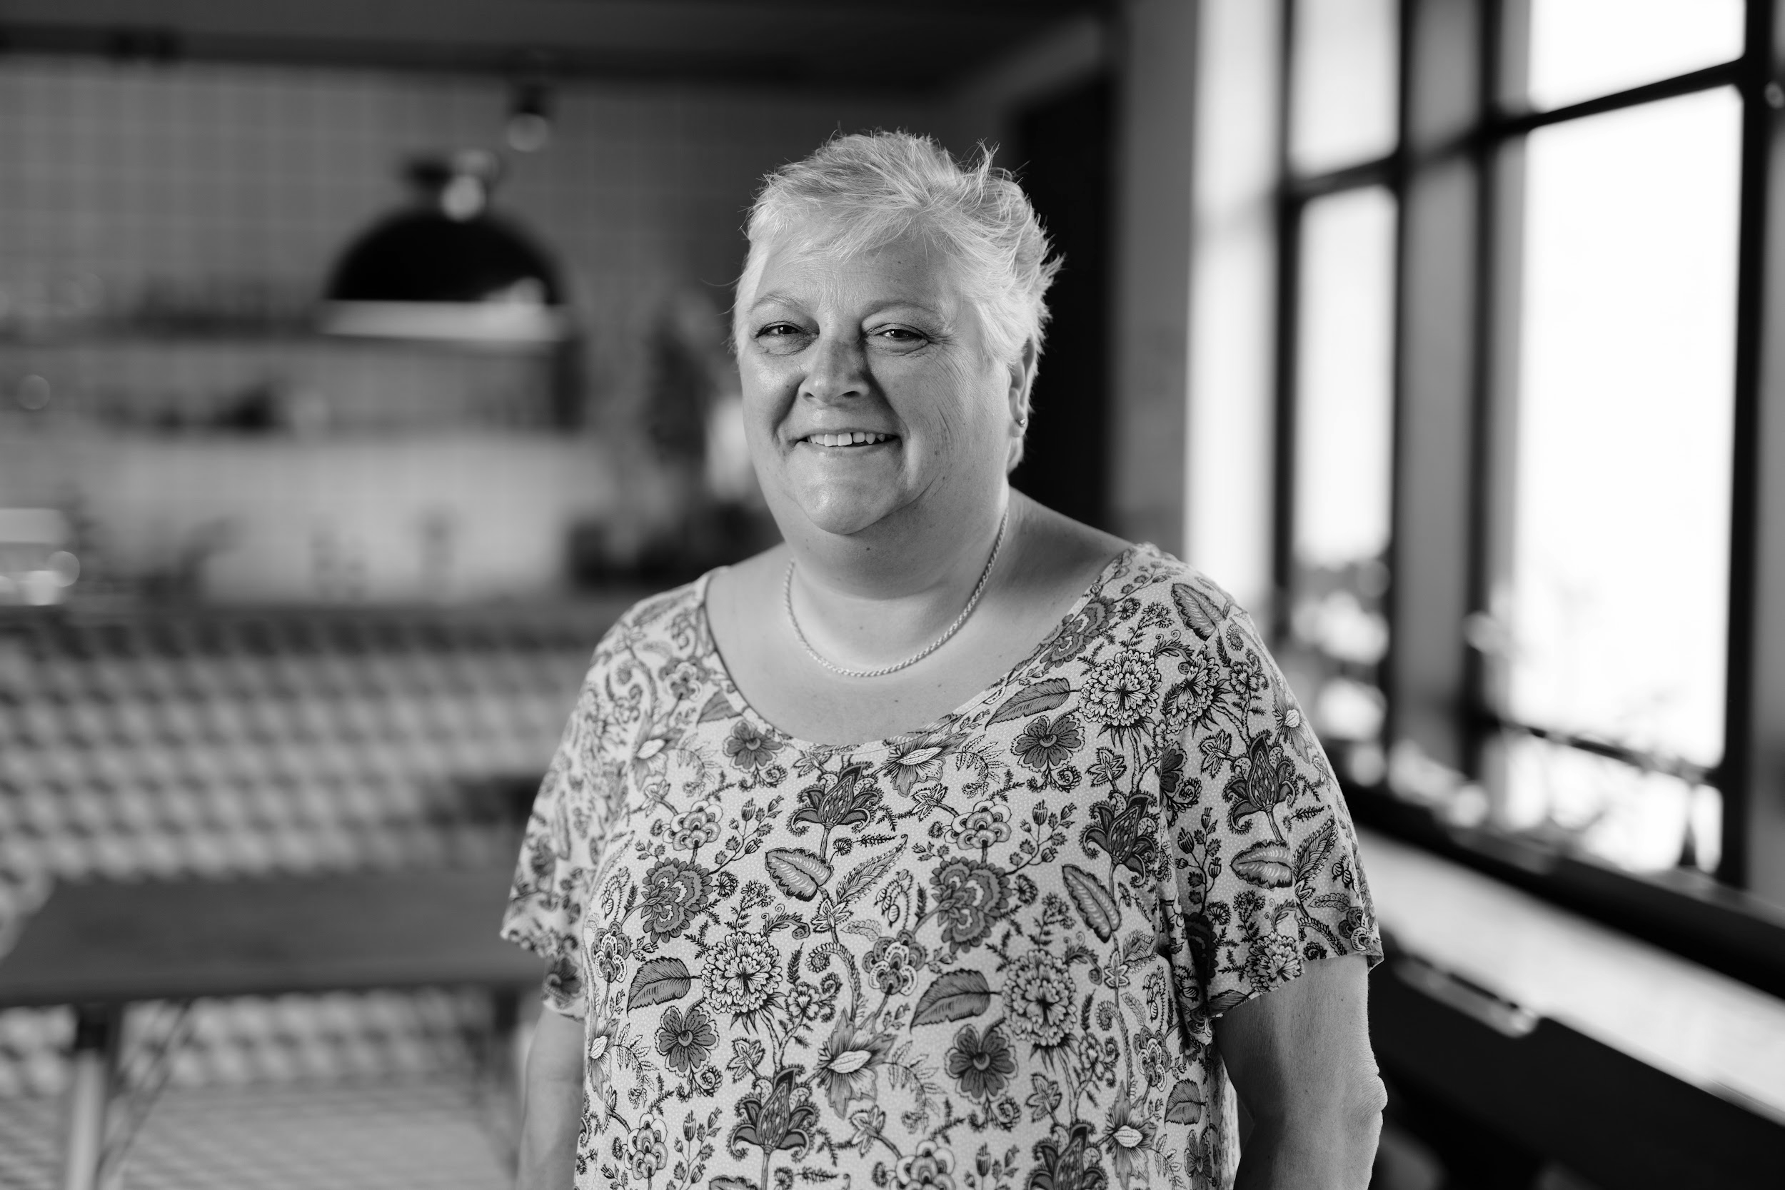
Alice is the Young Talent Director at SJT, where she nurtures emerging artists. She also collaborates with ARCADE working with the Pupil Referral Unit to engage and support students. A musician, director, and facilitator, Alice is passionate about using creative arts to inspire and empower young people. Photo: Tony Bartholomew
Vanessa Nolan (she/her)
Workshop / Talk: Tax for Self-Employed Artists
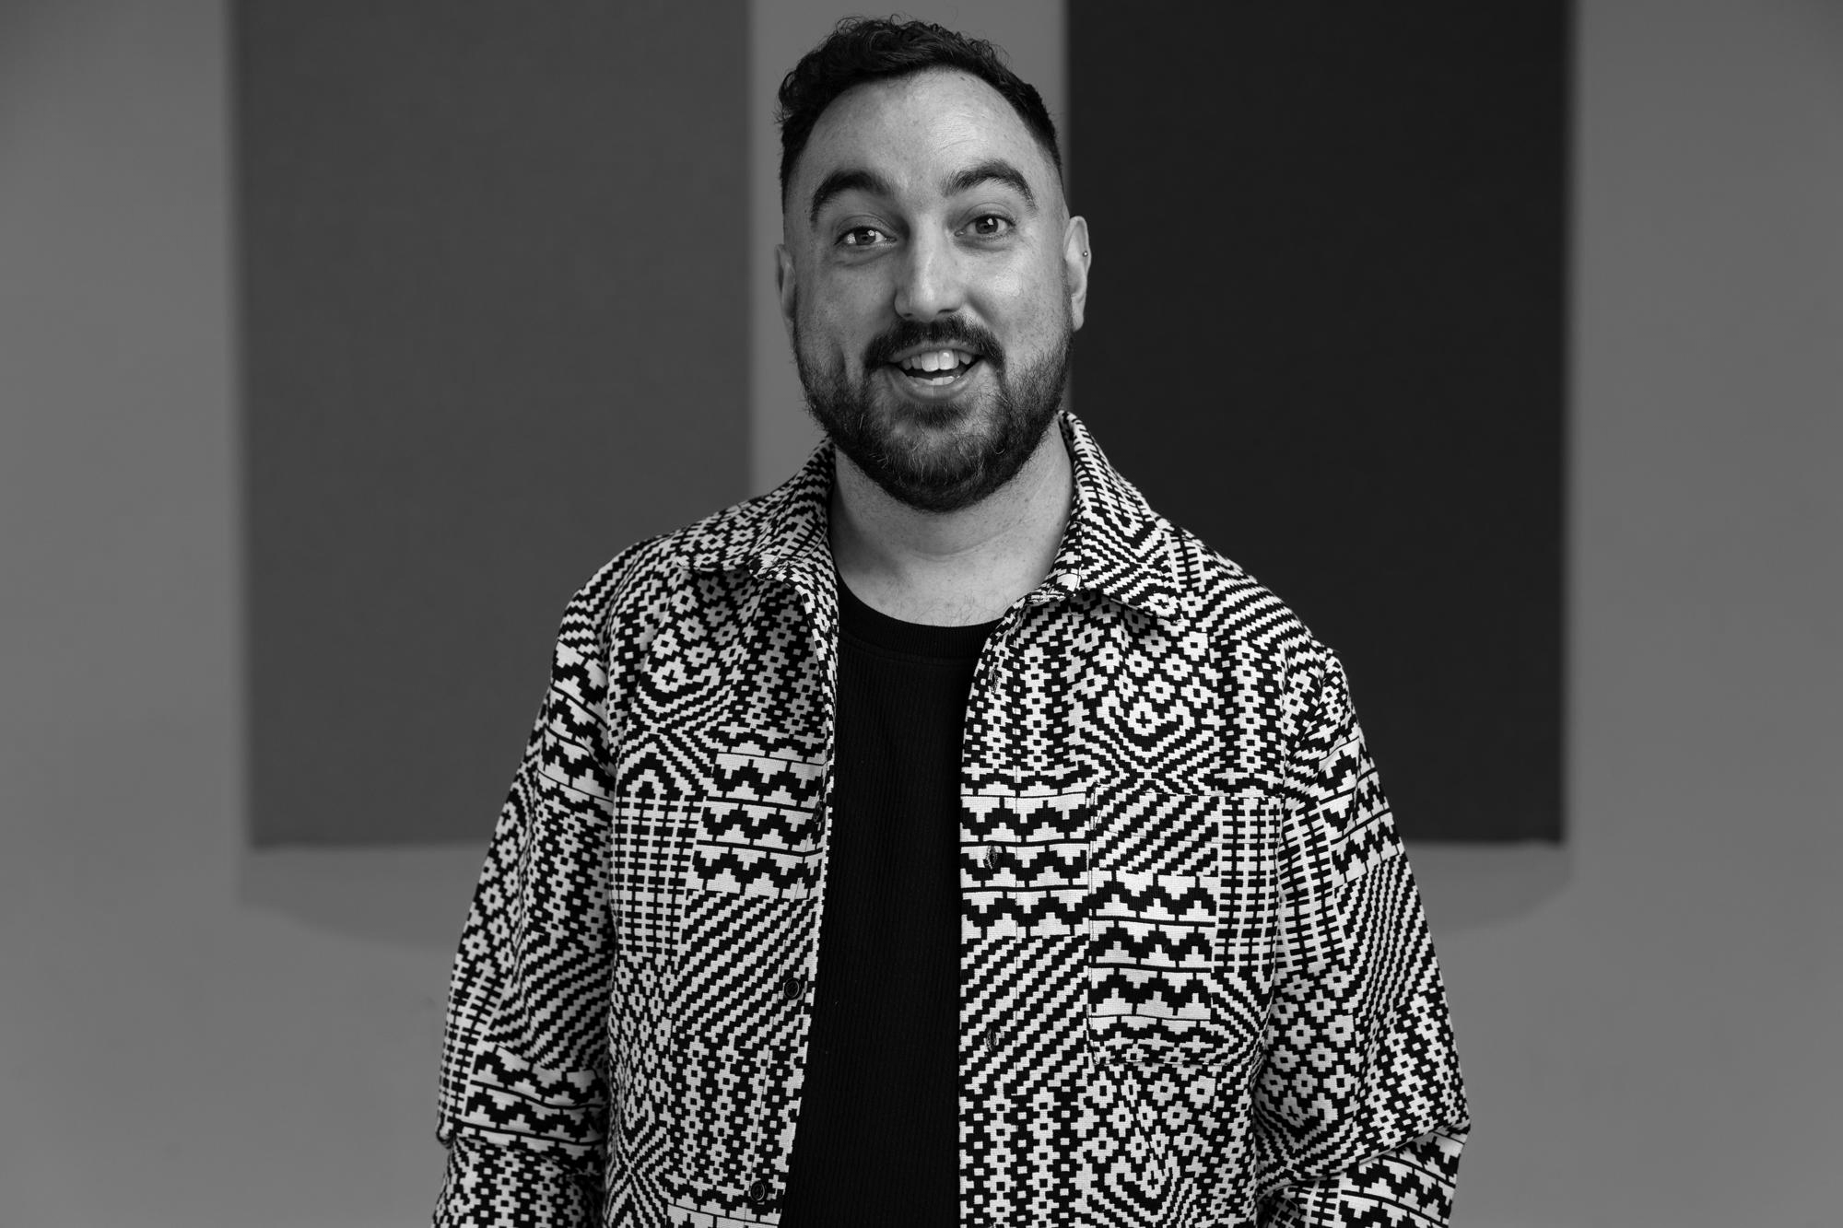
Vanessa is a Chartered Accountant with over 30 years experience largely working in companies but across a variety of industries, including not-for-profit, charities and creative arts. Photo: Tom Arran
Matt Harper-Hardcastle - Next Door But One Theatre (he/him)
Workshop / Talk: Inclusive Theatre-Making
Matt is an award-winning, disabled theatre director, writer and facilitator. Having worked for regional theatres, universities, and national equality and diversity campaigns, Matt founded Next Door But One in 2013 to create a home for all those who shared his passion for theatre, community and co-production. Photo: James Drury.

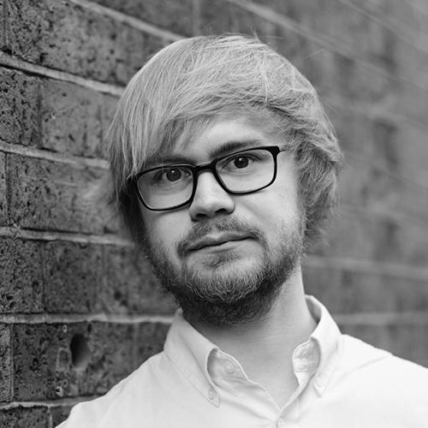
Jack Heaton - Stephen Joseph Theatre (he/him)
Workshop / Talk: Marketing 101
Jack is Head of Marketing at the Stephen Joseph Theatre in Scarborough. He’s worked in arts marketing for over a decade and is passionate about making theatre and culture accessible to all. He’s previously worked at Paines Plough, the National Theatre, New Diorama Theatre and Arts Council England. Photo: Rebecca Need-Menear
Toni-Dee Paul (she/they)
Workshop / Talk: Making Artist Access Riders
Toni-Dee is Associate Director at Selina Thompson Ltd, Associate Artist of award winning company One Tenth Human and facilitates new approaches to access & wellbeing for and with other artists – to aid better ecologies of care.
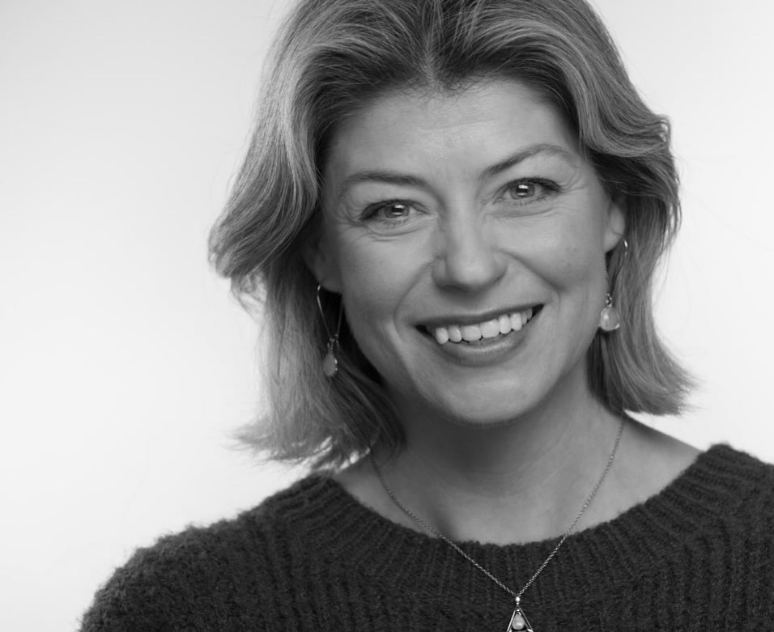
Elizabeth Boag (she/her)
Workshop: Public Speaking for Actors and Non-Actors
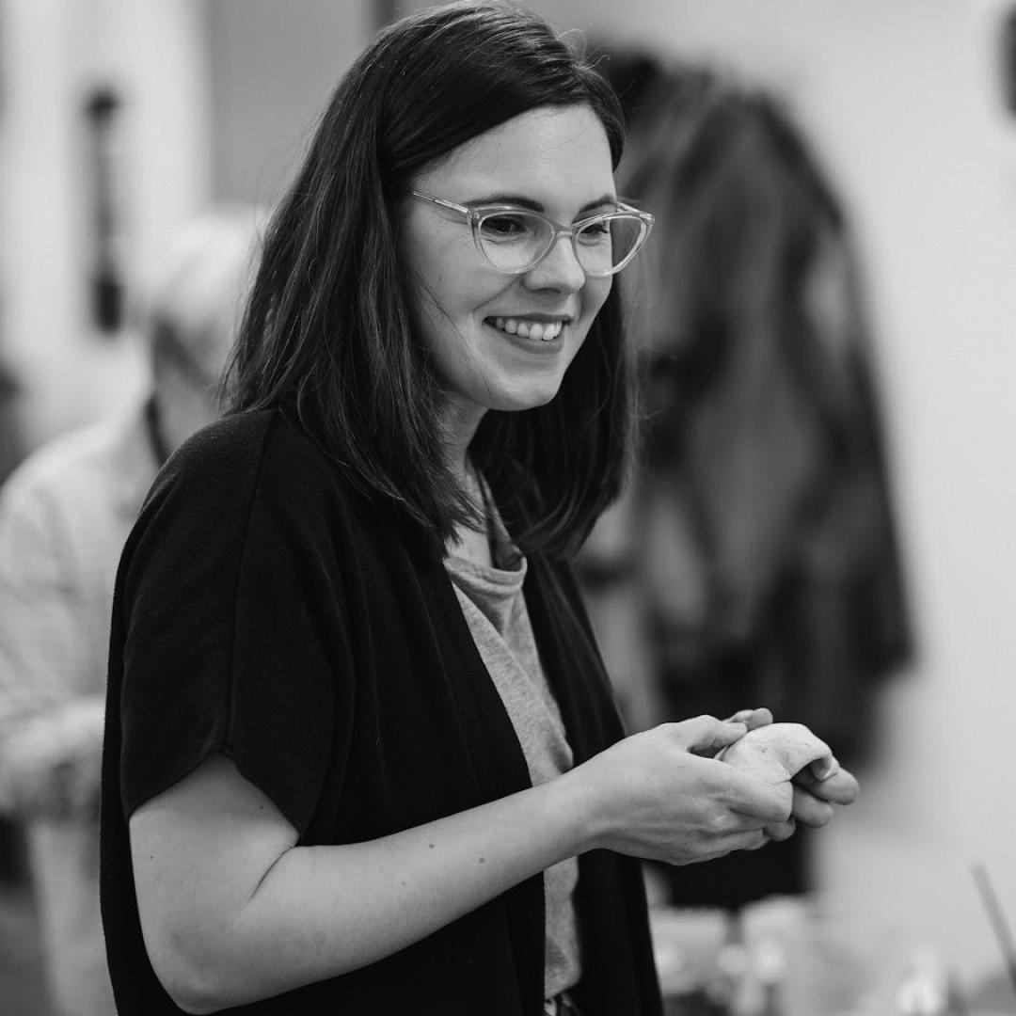
Elizabeth has been an actress for over twenty years, working in theatre, film, television and radio. She is one of the directors of Scarborough Film Festival; a tutor in Acting at Coventry University, Scarborough; a qualified Executive Coach; and she has also worked as a corporate actor and facilitator specialising in communication skills since 2006. Photo: Gary Sidebotham
Rebecca Norris (she/her)
Workshop / Talk: Working in Ceramics
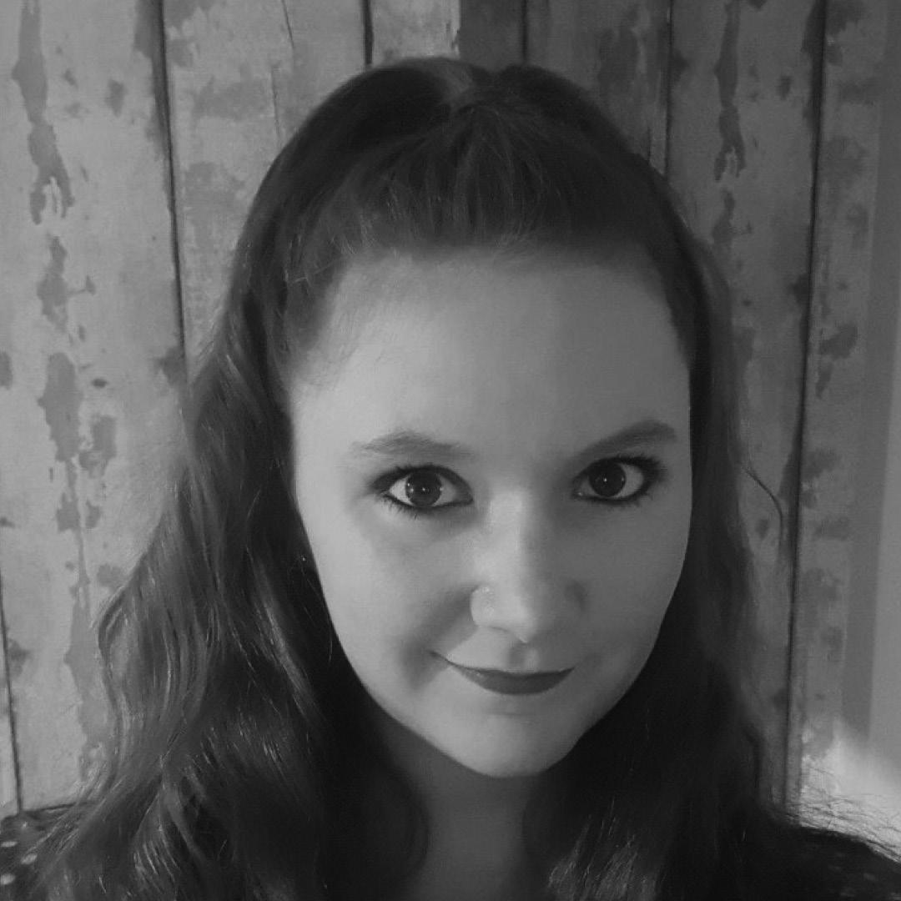
Rebecca is a potter and teacher who gained confidence to put her dreams into reality when she was a contestant on 'The Great Pottery Throwdown'. She now runs workshops, courses and pottery experiences in the Scarborough area.
Hayley Clark - East Riding Libraries (she/her)
Workshop / Talk: Working With Schools & Libraries
Hayley Clark is the Arts in Libraries Officer for East Riding Libraries. Hayley plays a key role in planning, programming, delivering, and evaluating arts and culture events in the heart of East Riding communities – libraries

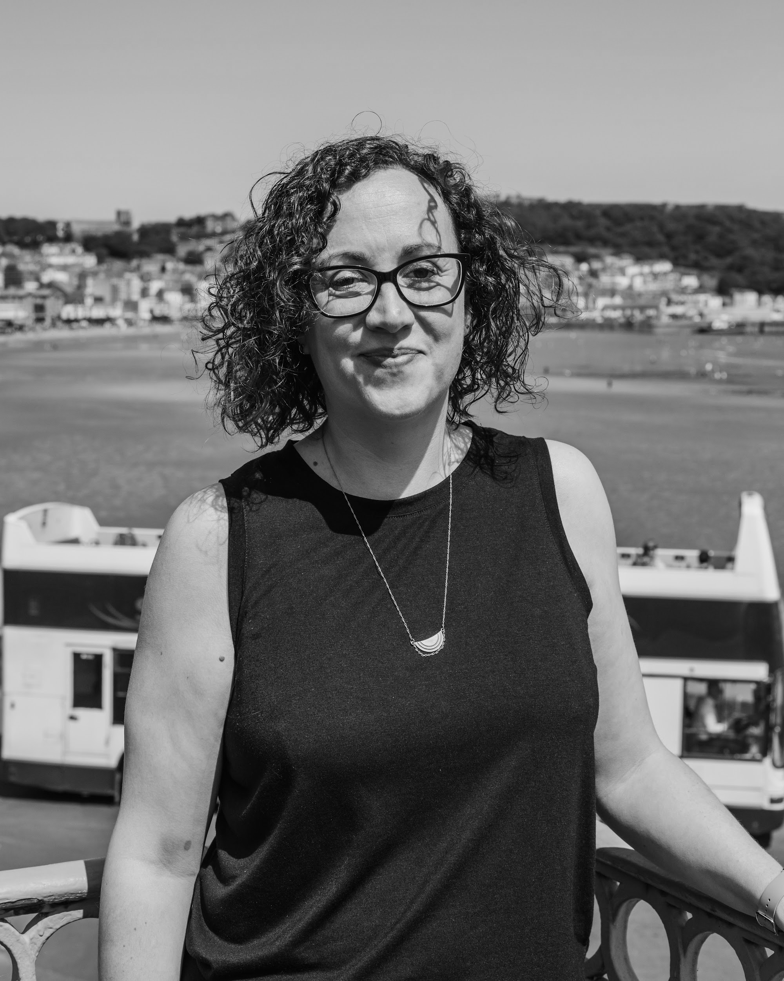
Rach Drew - ARCADE (she/her)
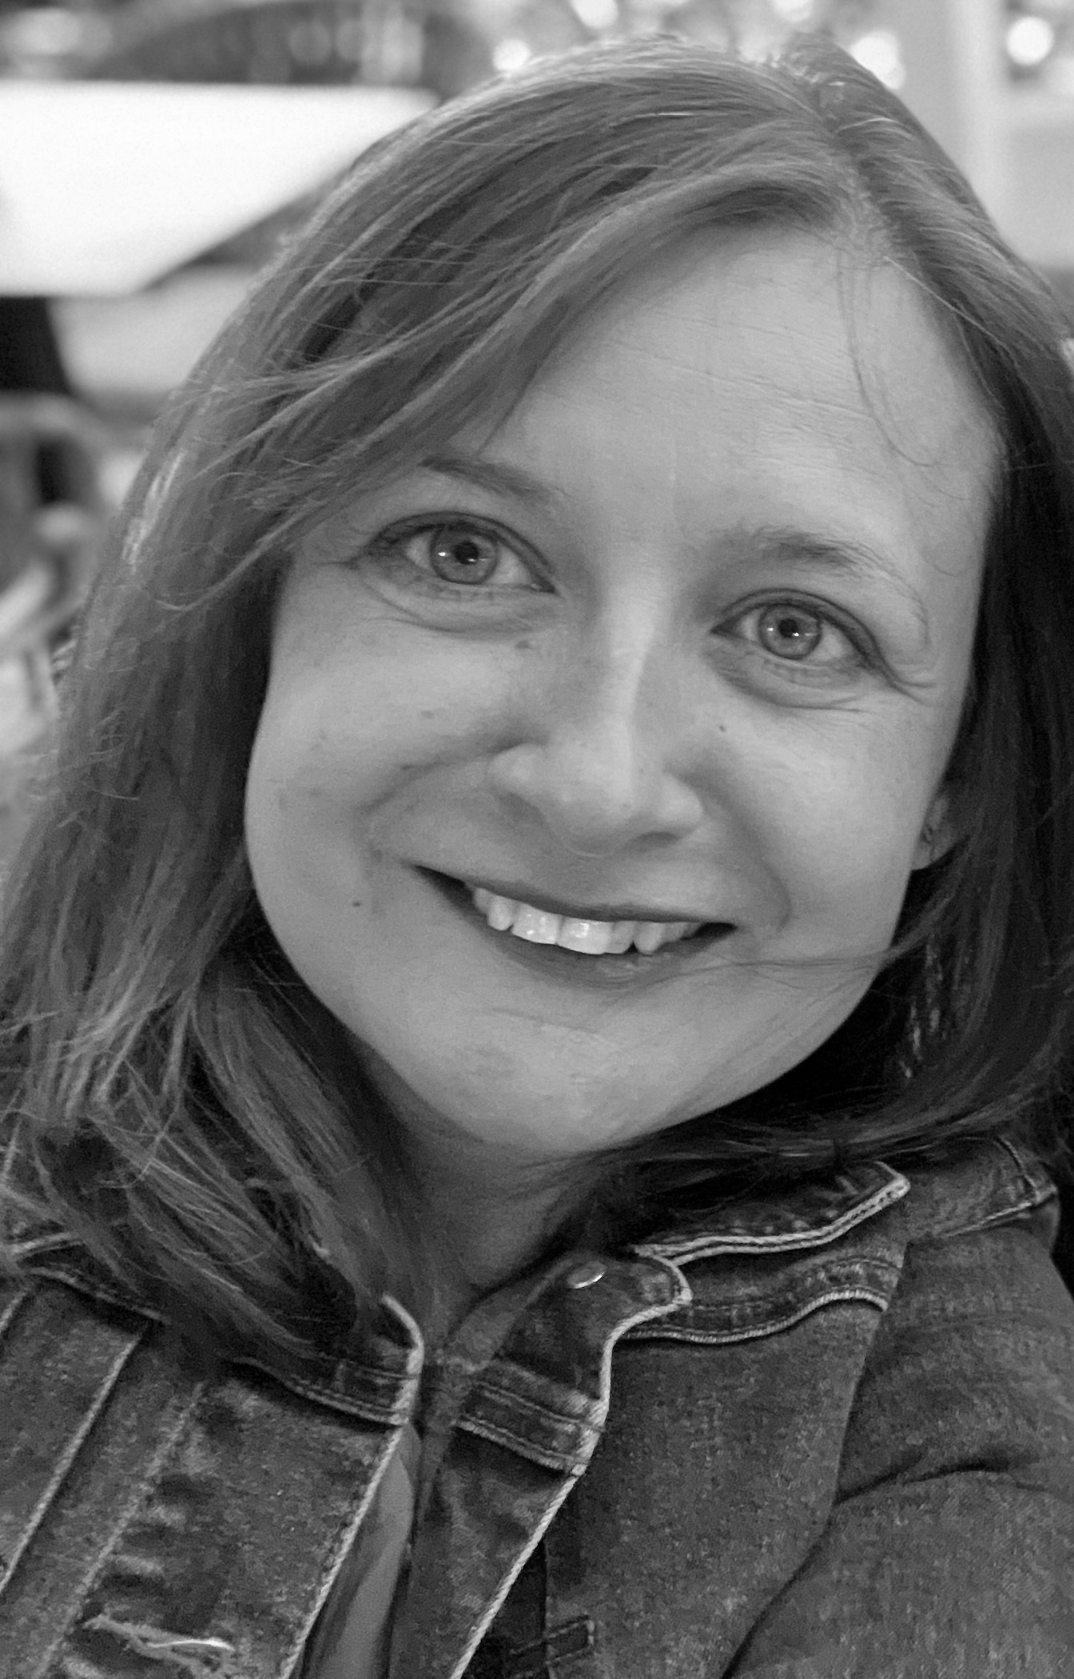
Rach is Co-Artistic Director and Founder of ARCADE and a Trustee of international contemporary performance festival, Transform. Growing up in Bridlington, Rach has worked across culture, from youth & community arts to large scale outdoor festivals and events. Rach is highly experienced in company setup and development and has fundraised in excess of 2 million pounds for arts projects throughout the course of her career. Photo: Matthew Cooper
Christine Rostron - Education Producer ARCADE (she/her)
Workshop / Talk: Working With Schools & Libraries
Christine Rostron is Education Producer for ARCADE. Current projects include ‘New Shores’ a locally-rooted creative partnership between ARCADE, KIT Theatre, Scarborough Museums & Galleries and four Scarborough schools. Christine has specialised in the museum and gallery sector for over 20 years, with expertise in developing partnerships for arts-based learning.
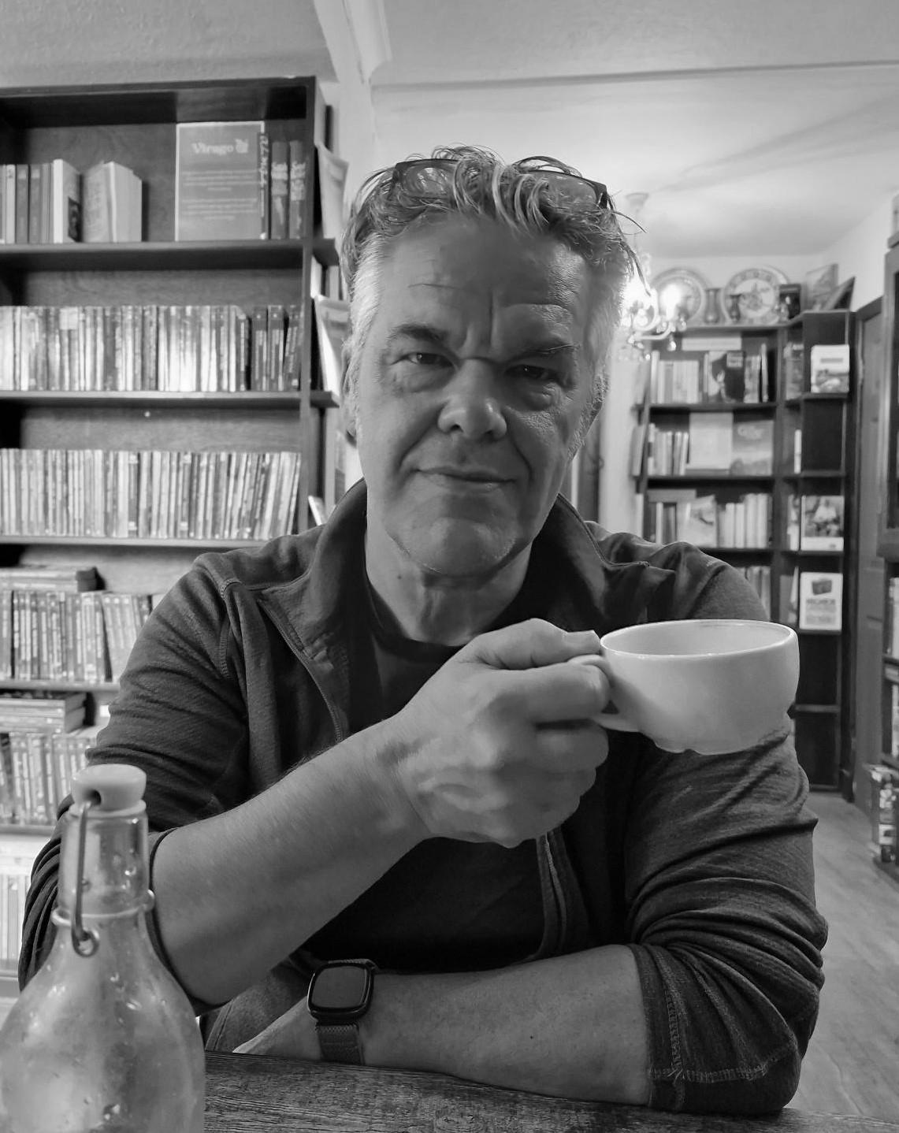
Lee Taylor - Scarborough Library (he/him)
Workshop / Talk: Working With Schools & Libraries
Lee Taylor is the Development Manager for North Yorkshire Libraries. He has a wide remit that includes devising and developing creative projects with artists in libraries across North Yorkshire and managing cultural activities with partners across different sectors. Photo: Dorcas Taylor
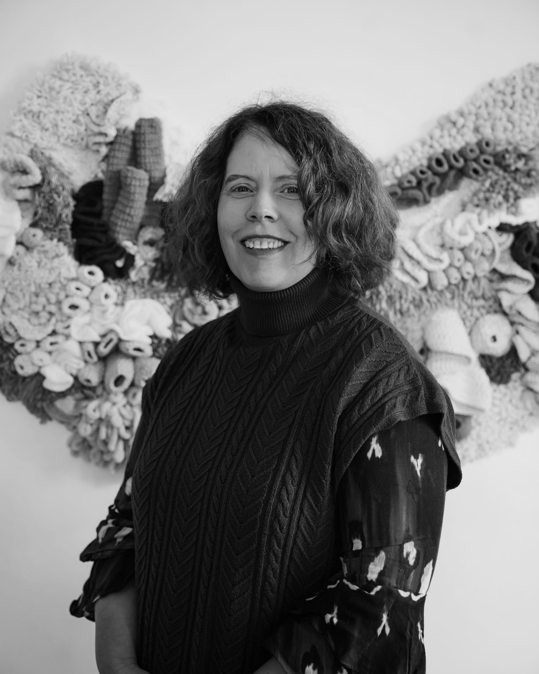
Jayne Shipley - Scarborough Museums Trust (she/her)
Workshop / Talk: Space to Be / Scarborough Museums Trust
Jayne Shipley is Community Engagement Officer for Space to Be, Scarborough Art Gallery. She works democratically with participants to create connections within our
communities, the gallery collection, exhibitions and our unique environment. Photo: Matthew Cooper
Produced by ARCADE and The Stephen Joseph Theatre, supported using public funding from Arts Council England.

