Circle Update – Jan 2021

Traditionally, we don’t do a Circular in January, as it’s always a quiet month for us – your next one will be with you towards the end of February.

But we wanted to drop you a line just to let you know that our core team are currently beavering away to bring you entertainment at the SJT in 2021. We’re not quite sure exactly when that will be just yet, but we’re determined to invite you back into the building as soon as we’re able to, still following the same Covid security measures that we know made you feel safe last year.

We don’t want to give too much away at the moment, but we’re all really excited about our summer season – if we can do what we hope to, we think you’re going to love it.

Before then, things are still flexible. Our creative producer is talking to various visiting companies in the hopes that we can bring you some shows in the spring, and we’re also keeping a close eye on what films are being released with a view to getting our cinema up and running again as soon as we can.

Once we can announce anything, we promise you’ll be the first to know.
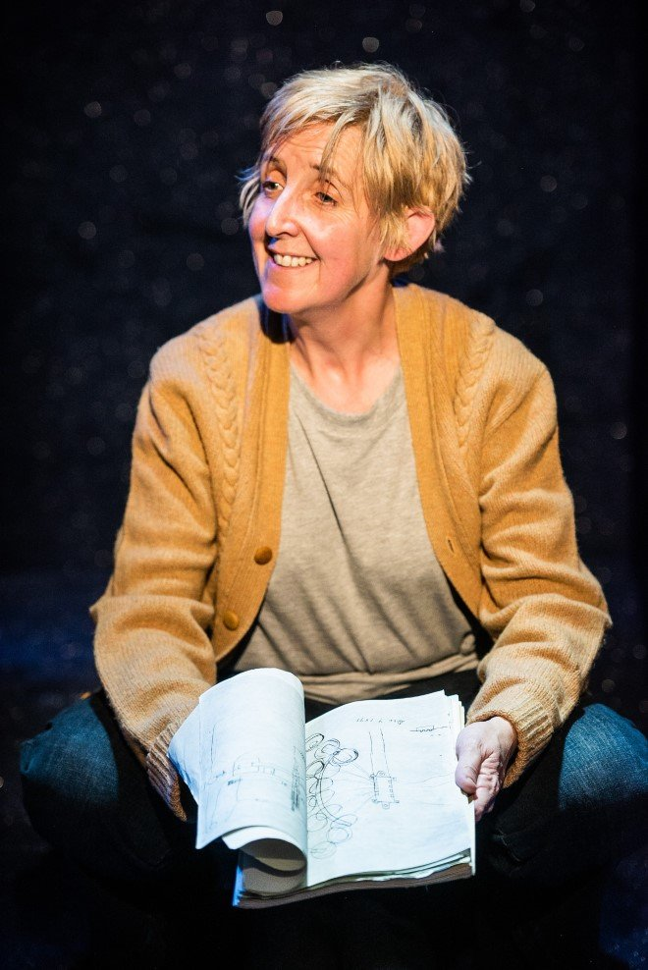

One concrete piece of news is that The Greatest Play in the History of the World, starring the fabulous Julie Hesmondhalgh, is moving. It was due to be in our Round from 9 to 13 March, but will now visit us from 18 to 22 May.

If you’ve booked for that, you should already have had an email from us about the change of dates. If you haven’t booked, take a look here - it’s a really uplifting and magical show – just what we need at the moment!

And once again, we want to thank you, our wonderful Circle members, for all your support over this past year, which has been so difficult for everyone.

It’s such a cliché to say we couldn’t do it without you – but we really couldn’t!

Yours,

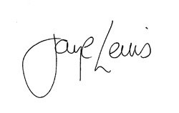

Jaye Lewis
(currently covering while Steph is on maternity leave)

PS – if you haven’t caught either of our online offerings yet, do hurry – the audio version of Alan Ayckbourn’s Haunting Julia, performed by the author himself, ends on Sunday; the film of The Snow Queen, directed by Paul Robinson, is only available until midnight on 15 February - you can read more about both here.

PPS - we are currently working on building a new and improved website and we'd like a couple of volunteers to help test it out. If you're interested, please drop us a line!

